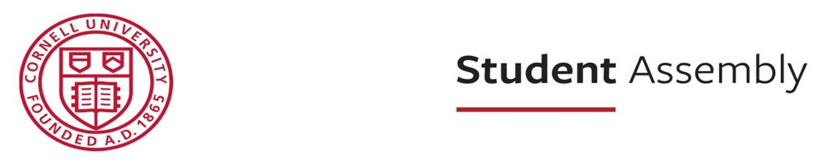

Student Assembly Meeting Agenda
March 26th, 2026
4:45-6:30 P.M.
Willard Straight Hall Memorial Room
Zoom
Meeting ID: 962 4676 6712 | Passcode: 673539
- Call to Order
- Reading of the Land Acknowledgment
- Consent Calendar
- Reports of Officers, Committees, and Liaisons
- Announcements
- Presentations
- Public Comment Microphone
- Second Readings
  - Resolution 67: Transferring Funds to the Multicultural Greek Fraternal Council
  - Resolution 73: Calling for Cornell to Improve its Land Acknowledgement and Recognize the Benefits Obtained through the Morrill Act of 1862
    - R73 Appendix & Notes
  - Resolution 75: Reassessing the Financial Relationship Between Cornell University and the State of Qatar
  - Resolution 77: Improving Communication from Housing & Residential Life to Students About Building-Wide Maintenance Issues
  - Resolution 78: Recommending an Adequate Provision of Course Information to Students Prior to Course Enrollment
- Third Readings
  - Resolution 57: Ensuring Equitable Evaluation of Special Projects Funding Request
    - R57 Appendix & Notes
  - Resolution 60: Free Laundry
  - Resolution 63: Recognizing September 25 and Establishing a “Survey Service Window” Administered by Student & Campus Life
  - Resolution 69: Urging Cornell to Support Higher TCAT Funding
  - Resolution 70: The Last Straw: Single-Use Plastic Phaseout
    - R70 Appendix & Notes
  - Resolution 71: Grade Transparency
  - Resolution 72: Alleviating Preliminary Examination Overloads
  - Resolution 74: Transparency in First-Year Program House Access and Placement Outcomes
- Appointments and Vacancies Calendar
- Adjournment

