MINUTES
Campus Welfare Committee
September 27, 2016
1:00pm – 2:00pm
Day Hall 305

Call to Order
  - Committees members in attendance: Ellis Leow, Matt Indimine, Joseph Anderson, Linda Copman, Ulysses Smith
- Updates on 2015-16 Priorities
  - Labor Relations in Qatar
    - Matt I. has met with COLA briefly and they have indicated that they would like to follow up on the request from UA Resolution 6.
    - Matt will bring an update at the next CWC meeting.
  - Universal Restrooms/Facilities
    - We will invite Andrea Haenlin-Mott and her project manager to discuss the progress on the items outlined in UA Resolution 3 and future projects to continue the initiative.
  - Assessment of Diversity Offices/Structures
    - To be discussed at a future meeting.
  - Accessibility and Disability Inclusion
    - The CWC will invite the ADA Coordinator team, likely in the spring, to discuss next steps for moving forward with some of the items proposed last term, particularly around web accessibility and making programs more accessible.
- Tobacco-Free Campus Initiative
  - Introduction of Guests
    - Ted Schiele, Beth McKinney, Dan Olbrych, Sharon Dittman, Kristi Mahoney
  - Review of Current Information
    - Currently, there is only minimal data collected from undergraduates, and no data from employees
      - Why is the data important? Do we actually need to collect data about the campus behavior or can we just act on this, given what we know?
        - There is a question of cost. If we do not have data, we cannot estimate the projected cost of changing health insurance or offering additional cessation services.
    - Can some questions be added to the PULSE?
    - Is the information from the alcohol.edu program published? How is it used?
      - It is published on Gannett’s website and used to influence programming and initiatives.
    - Does Cornell participate in the National College Health Assessment survey?
      - Yes, but this was last conducted in 2010 and is currently under revision.
    - The Alcohol and Social Life Survey was conducted in Fall 2015 in partnership with the Student and Campus Life Research Committee.
      - See partial results slide from Sharon Dittman appended to minutes.
    - Data about our insurance plans is needed
      - 50 percent of students are enrolled in the Student Health Plan (SHP), and it does cover cessation programs with no copay.
      - Beth McKinney will verify what is covered under employee insurance plans and see if there are differences between statutory and endowed benefits.
    - How should this initiative be approached? Are we looking to go completely tobacco-free, smoke-free, phased implementation, or something else?
      - How would any of these options be enforced?
        - The current policy is enforced by the building coordinators and varies.
        - There is also a strong reliance on community enforcement and driving a culture change.
      - In 2016, we know a lot more about tobacco use and its impacts than we did 10-15 years ago.
      - The list of institutions that have gone tobacco-free or smoke-free are not necessarily comparable to Cornell, particularly in terms of our sprawling campus and diverse population with a high number of international students.
        - Is there a way that we can cut the data that was collected from the previously mentioned surveys to gather information about smoking among the international population at Cornell? Sharon will investigate.
        - See: Student Region of Origin, Fall 2015 (http://www.cornell.edu/about/facts.cfm)
      - Yale is going tobacco-free and so is Binghamton, which also have large international populations that were cited as a concern.
      - Are there any legislative initiatives on the state level that are addressing smoking?
        - Linda will look into a possible law around not smoking in a vehicle is someone under 18 years old is inside.
        - The SUNY regents have voted to go tobacco-free, but it must be passed by the legislature.
    - How can we begin to discuss this matter in terms of the organizational impact?
      - We need to begin to talk about the lost productivity of students and employees due to tobacco-use.
    - Why do we not discuss this in the same manner as other addictions?
      - We have policies and protocols for dealing with individuals who come into the workplace intoxicated or dealing with another addiction. Why not also treat this as an addiction?
    - Should we use a referendum?
      - If we did a referendum, it would need to be coupled with a period of education about the issue for each constituent group, instead of being pushed as a polarizing topic.
      - Linda is willing to share some insight on educating the public and crafting language in a referendum based on her experience.
  - DDD (Deadlines, Dates, Deliverables)
    - There are seemingly four options on the table:
      - Tobacco-free (with a phased implementation)
      - Having designated smoking areas across campus
      - Extending the current 25ft minimum in the policy
      - Campus-wide Referendum
    - For the next meeting:
      - Ted and Beth will provide some potential educational materials that could be used.
      - Sharon will provide additional data from Gannett, as discussed.
      - Beth will provide information about health insurance plans.
      - The committee will narrow down options and vote on a way to proceed.
- Questions
- Adjournment
  - Next Meeting: Tuesday, October 25th at 1pm in Day Hall B12

Data (for undergraduates only) from the Fall 2015 Alcohol and Social Life Survey:
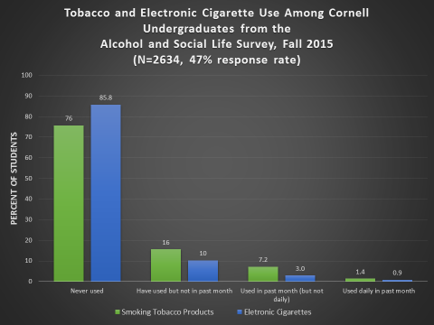

For those interested in history, check out the data here: http://www.gannett.cornell.edu/topics/drugs/tobacco/index.cfm

