GPSA Resolution 15:
Subsidizing the BRB’s 25th Anniversary Improvements
Sponsored by: Tyler McCann

WHEREAS, the Big Red Barn Graduate and Professional Student Center (BRB) celebrated its 25th anniversary in 2017; and

WHEREAS, the BRB conducted a crowdfunding drive during the month of November to finance new additions to the Center; and

WHEREAS, the BRB raised $7,651 from the crowdfunding drive of which $5,537 was spent on a wood pellet stove; and

WHEREAS, the president of the GPSA reached out to the BRB manager, Kris Corda, in Fall 2016 to determine how successful the fundraising drive was, and to share the possibility of financial support from the GPSA for this drive; and

WHEREAS, two remaining improvements have not been fully funded: a piano (plus transportation), and additional bike racks (plus curb removal) adjacent to the BRB; and

WHEREAS, Corda informed the Appropriations Committee that a baby grand piano was located in the BRB until 2014 when building renovations began. This piano was used by students, particularly during end of semester and holiday parties. The BRB paid for annual maintenance, but determined the age and condition of the previous piano did not warrant the cost of moving the piano back into the BRB upon completion of renovations; and

WHEREAS, the Appropriations Committee agreed upon the intrinsic importance of facilitating opportunities for public arts and music, and acknowledge that this opportunity expands the range of possible activities available at the BRB to members of the graduate and professional student community; and

WHEREAS, the BRB has received comments from students that existing bike racks at the Center are insufficient to meet current and future demand of bicyclists wanting to attend events; and

WHEREAS, incorporation of these bike racks will complement the free bike-sharing initiative, Big Red Bikes, and increase sustainable transportation options at Cornell by facilitating greater use of bicycles for transportation to, from, and on campus¹; and

WHEREAS, the BRB currently has $2,114 remaining from its fundraising drive to put towards these two remaining projects. The cost of the piano would be $5,000, and the cost of the bike racks would be $6,100. The estimated cost of both improvements after accounting for BRB’s balance is $8,986 (see appendix); and

WHEREAS, the Appropriations Committee discussed the interest of its members and the opinions of the assembly that the rollover funds should be actively used, and not passively held on to, for graduate and professional student community benefit; and

WHEREAS, the GPSA rollover account stood at approximately $18,000 as of April 6th, 2017;

BE IT THEREFORE RESOLVED, that the GPSA will grant the BRB no more than $3986 for the purchase and installation of 3-4 inverted U-loops in front of the Center;

BE IT FURTHER RESOLVED, that the GPSA will grant the BRB no more than $8986 for the purchase, installation, transportation of 3-4 inverted U-loops in front of the Center and a piano in the Center;

BE IT FINALLY RESOLVED, that the GPSA recognizes and commends the Graduate School in its financial support of the the BRB through major building renovations, operations, and $6000 annually for general expenses. We strongly encourage the Graduate School to provide greater financial support during the current and any future improvement projects at the BRB like those above, which specifically promote greater participation from the graduate and professional student community;

RESPECTFULLY SUBMITTED,

TYLER MCCANN
GPSA Appropriations Committee Chair

- http://csc-production.s3.amazonaws.com/2014/04/15/02/46/38/230/CAPUpdate2013Roadmap2014_2015.pdf

APPENDIX
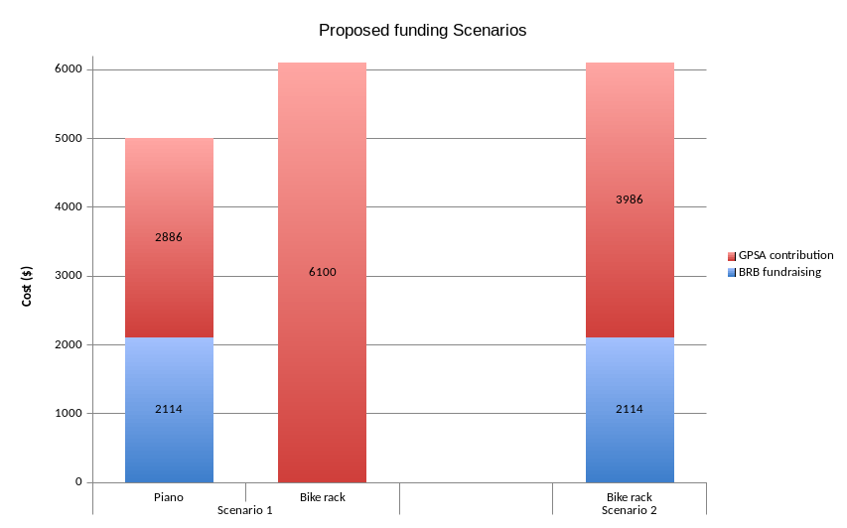
Scenario 1 - Fund both piano and bike rack. Total cost to GPSA = $8986
Scenario 2 - Fund only bike rack. Total cost to GPSA = $3986

